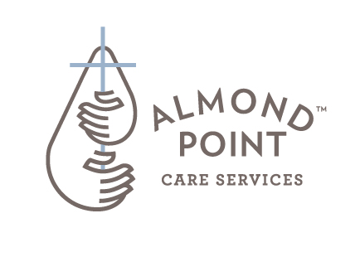

**Supporting Churches**

**Supporting Families**

**Supporting Community**

**Almond Point – “Coffee Talks”**

**60 Minute Gatherings**

**PRESENTATION TOPICS**

* **“Old Age, what’s so different today?”** – Changing demographics in aging & Society!
* **“My Mom & Dad need more care, HELP!** – How to begin looking at options
* **“Living Safely at Home”** – The best place to age!
* **“Old Age, How & Where does the church fit in”** – Healthcare issues & working together with your church
* **“Deciphering Medicare & Medicaid” –** Understanding costs of care for an aging person
* **“Changing Healthcare System, & the changing face in Care givers”** – lots have changed with growing old
* **“What is Palliative Care”** – A growing trend and need
* **“Dementia & Alzheimer’s”** – Dealing with tough questions
* **“Hospice & End of Life, Is it really a good option?”** – Learn about the benefits of Hospice towards end of life
* **“Financial Preparation for the long haul**” – reviewing financial considerations



**Supporting Churches**

**Supporting Families**

**Supporting Community**

**APCS, HELPING CHURCHES HELP PEOPLE**

**“ABCs of Caring for Seniors Seminars”**

* **Held in local Community Centers, 4 times a year in your area**
  + **Thursdays & Saturdays 8:30 AM – 12 Noon**
* **Involvement and presentations by Almond Point, Church Pastors, local care providers**
* **Almond Point local promo in area churches, Community groups**



**Supporting Churches**

**Supporting Families**

**Supporting Community**

**AGING SECTION:**

**(Almond Pt Group)**

Demographics

Changing Healthcare

System

Cost of care options

**BURDEN SECTION:**

**(Church/Community)**

Church support

Working together

Stories

**CARING SECTION:**

**(Providers)**

Living Safe at Home

Care Options

When is it time to

Move?